SP Documentation of Client_RebuildReorgIndex
Overview
The stored procedure [dbo].[Client_RebuildReorgIndex] is designed to automate the maintenance of SQL Server indexes. It reorganizes or rebuilds indexes based on their fragmentation level and page count, updating statistics afterward. This procedure helps optimize database performance by ensuring indexes are efficient.
Parameters
@page_count (BIGINT): Minimum page count for an index to be considered for reorganization or rebuild. Default is 100.
@Reorg_Min_Frag (INT): Minimum fragmentation percentage to trigger an index reorganization. Default is 10.
@Rebuild_Min_Frag (INT): Minimum fragmentation percentage to trigger an index rebuild. Default is 30.

Table Structures:
FragData Table:
Column Name | Data Type | Description
ID | INT IDENTITY | Unique identifier for each row.
RunDate | SMALLDATETIME | Date and time when the record was created.
SchemaName | NVARCHAR(100) | Name of the schema containing the table.
TableName | NVARCHAR(100) | Name of the table.
IndexName | NVARCHAR(100) | Name of the index.
PartitionNum | INT | Partition number of the index.
PartitionRows | BIGINT | Number of rows in the partition.
PreAvgFragPct | DECIMAL(18,5) | Fragmentation percentage before maintenance.
PostAvgFragPct | DECIMAL(18,5) | Fragmentation percentage after maintenance.
PrePageCt | BIGINT | Number of pages before maintenance.
PostPageCt | BIGINT | Number of pages after maintenance.
DiffPageCt | BIGINT | Difference in page count before and after maintenance.
DiffPageCtPct | DECIMAL(18,5) | Percentage difference in page count.
RebuildReorgQry | NVARCHAR(500) | Query to reorganize or rebuild the index.
ErrMsg | NVARCHAR(500) | Error message if any error occurred during maintenance.

FragDataHistory Table:
Column Name | Data Type | Description
RunDate | SMALLDATETIME | Date and time when the record was created.
SchemaName | NVARCHAR(100) | Name of the schema containing the table.
TableName | NVARCHAR(100) | Name of the table.
IndexName | NVARCHAR(100) | Name of the index.
PartitionNum | INT | Partition number of the index.
PartitionRows | BIGINT | Number of rows in the partition.
PreAvgFragPct | DECIMAL(18,5) | Fragmentation percentage before maintenance.
PostAvgFragPct | DECIMAL(18,5) | Fragmentation percentage after maintenance.
PrePageCt | BIGINT | Number of pages before maintenance.
PostPageCt | BIGINT | Number of pages after maintenance.
DiffPageCt | BIGINT | Difference in page count before and after maintenance.
DiffPageCtPct | DECIMAL(18,5) | Percentage difference in page count.
RebuildReorgQry | NVARCHAR(500) | Query to reorganize or rebuild the index.
ErrMsg | NVARCHAR(500) | Error message if any error occurred during maintenance.

Logic Flow
- Setup:
- Get the current database ID.
- Drop and recreate the #data_spaces temporary table.
- Check for and create FragData and FragDataHistory tables if they do not exist.
- Insert current data from FragData into FragDataHistory and truncate FragData.
- Identify partitioned Data Spaces:
- Insert data space IDs of partitioned tables into #data_spaces.
- Collect Fragmentation Data:
- For each data space ID:
- Collect fragmentation data using sys.dm_db_index_physical_stats.
- Insert fragmentation data into FragData with appropriate reorganization or rebuild queries based on fragmentation levels and page count.
- Execute Rebuild/Reorg Queries:
- For each index in FragData:
- Execute the generated reorganization or rebuild query.
- Update statistics for the table.
- Update Post-Maintenance Fragmentation Data:
- Update FragData with post-maintenance fragmentation data.
- Calculate the difference in page counts before and after the maintenance.
Error Handling
- Transactions are used to ensure atomicity.
- Errors during data insertion or query execution are caught and logged in the ErrMsg column of FragData.
Example Usage
- To execute the procedure with default parameters:
EXEC [dbo].[Client_RebuildReorgIndex];
- To execute the procedure with custom parameters:
EXEC [dbo].[Client_RebuildReorgIndex] @page_count = 100, @Reorg_Min_Frag = 5, @Rebuild_Min_Frag = 30;
Notes
- Ensure the SQL Server Agent is configured to periodically execute this procedure for regular index maintenance.
- Review the FragData and FragDataHistory tables to monitor index maintenance activities and performance improvements.

Implementation process:

- Release the script (Client_RebuildReorgIndex) in SQL Server. 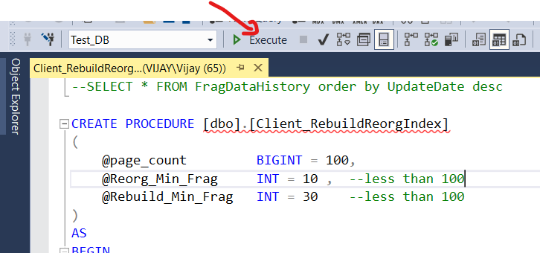

- Add the Execution query EXEC [dbo].[Client_RebuildReorgIndex]; in the command file or powershell file to run it daily for Rebuild or Reorg Indexes.

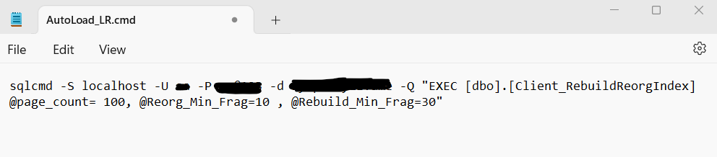
- Create the text file which will run the query SELECT * FROM FragData;
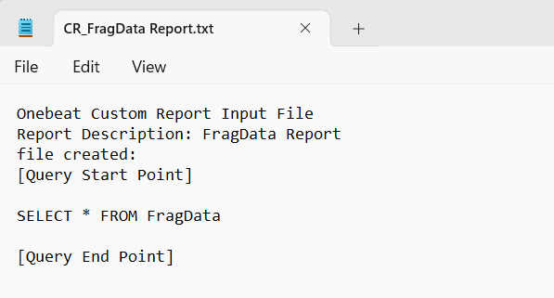
- Add in the custom report to get the records daily basis in through mail. 